Name: Hovan Hodges
Course: CST-305
Assignment Name: Project 1 - Visualize ODE with SciPy
Date: 5/10/2026

Responsibilities and completed tasks by each team member
I completed all tasks as I worked on this by myself.
System performance context description
When a computer network router receives traffic faster than it can process it, the excess packets are stored in a memory buffer (a queue). If the buffer simply fills up until it overflows, you get massive latency spikes (bufferbloat). Modern routers use algorithms like Random Early Detection (RED) to intentionally drop incoming packets at a rate proportional to how full the queue is, which forces sender systems (like TCP) to slow down and stabilize the queue.
Specific problem solved
I am modeling the queue length (q) of a network router over time during a high-traffic event. By solving the ODE, we can visualize how quickly the router's memory fills up and how the RED algorithm helps the system reach a stable equilibrium rather than crashing.
The mathematical approach for solving it
We can model the rate of change of the queue length as a fluid flow problem. The change in the queue size is equal to the incoming traffic rate minus the processing rate, minus the packets dropped by the RED algorithm.
$$\frac{dq(t)}{dt}=λ(t)-μ(t)-kq(t)$$
Where:
- q: The current number of packets in the queue
- λ: The incoming traffic rate
- μ: The router’s processing/forwarding rate
- k: The drop probability factor of the RED algorithm
The approach for implementation in code (e.g., algorithm, flowchart)
The implementation of this solution utilizes a straightforward, sequential pipeline. It leverages standard numerical computing libraries to bridge user-defined system parameters with mathematical ODE solving and error analysis. The program is built using NumPy for array manipulation and exact computations, SciPy (solve_ivp) for numerical integration, and Matplotlib for plot visualization.
Screenshots depicting key phases in the program execution
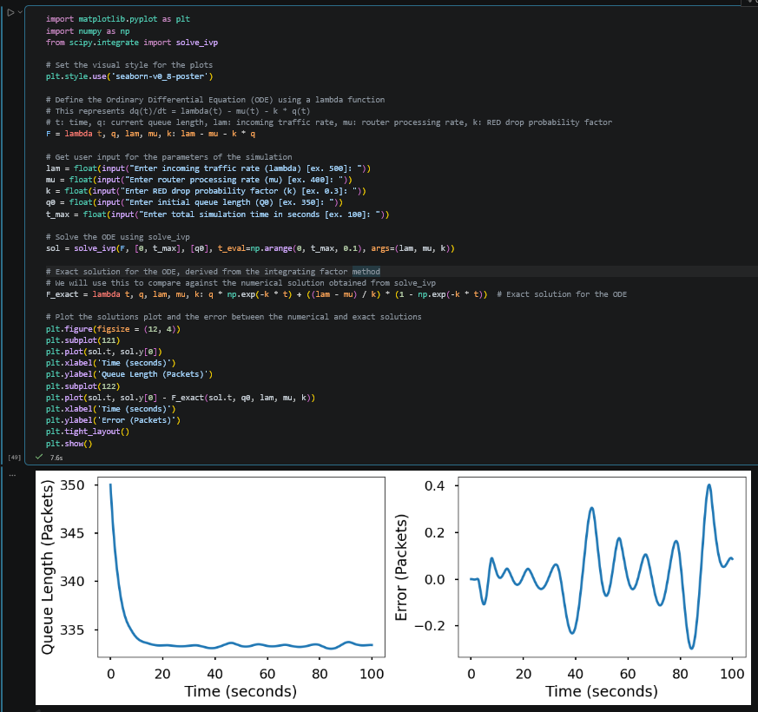
References for theory and code sources
- Bronson, R., & Costa, G. (2014). Schaum's Outline of Differential Equations (4th ed.). McGraw-Hill Education.
- Google’s Gemini
- Random early detection - Wikipedia
- Python ODE Solvers - Python Numerical Methods
README document written in Markdown, detailing how to install and run the program
The README.md document is posted within the Github and was uploaded alongside this PDF document inside Halo Learn.

